**Aaron Williams**

**Assignment 3**

**6 June 2017**

**Problem 1:**

Build a program that uses a single-dimension array to store 10 numbers input by the user. After inputting the numbers, the user should see a menu with two options to sort and print the numbers in ascending or descending order.

Output:

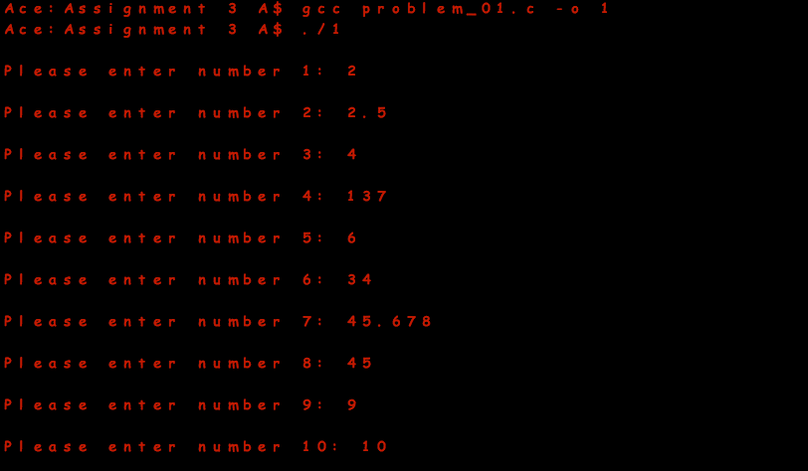

-Descending:

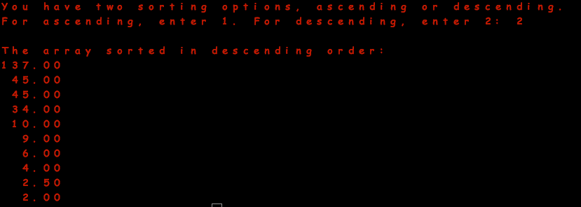

-Ascending:

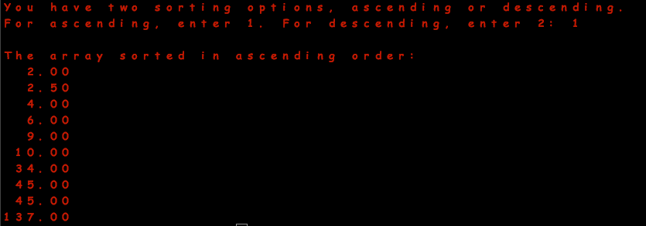

**Problem 2:**

Create a student GPA calculator. The program should prompt the user to enter up to 30 GPAs, which are stored in a single-dimension array. Each time the user enters a GPA, they should have the option to calculate the current GPA average or enter another GPA.

Output:

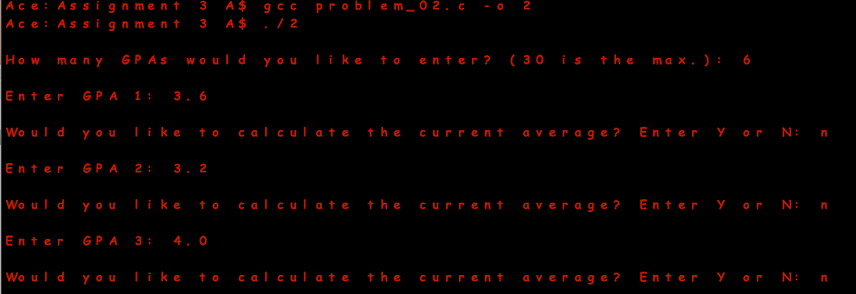

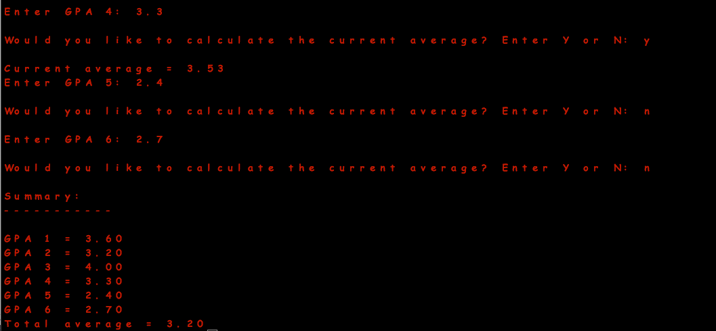

**Problem 3:**

Build a program the performs the following operations:

-Declares three pointer variables called iPtr of type int, cPtr of type char, and fFloat of type float.

-Declares three new variables called iNumber of int type, fNumber of float type, and cCharacter of char type.

-Assigns the address of each nonpointer variable to the matching pointer variable.

-Prints the value of each nonpointer variable.

-Prints the value of each pointer variable.

-Prints the address of each nonpointer variable.

-Prints the address of each pointer variable.

Output:

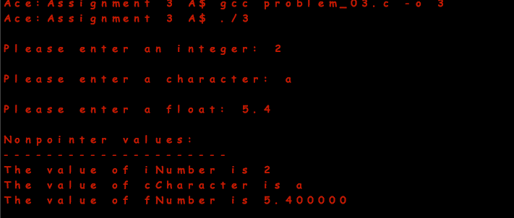

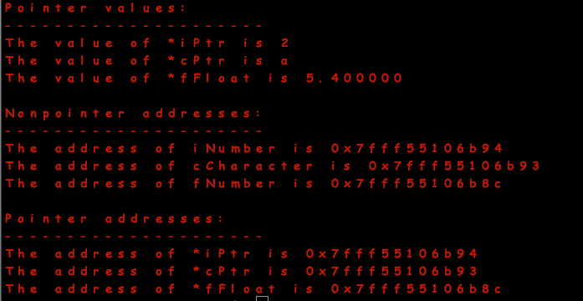

**Problem 4:**

Create a dice rolling game. The game should allow a user to toss up to six dice at a time. Each toss of a die will be stored in a six-element integer array. The array is created in the main() function but passed to a new function called TossDie(). The TossDie() function will take care of generating random numbers from one to six and assigning them to the appropriate array element number.

Output:

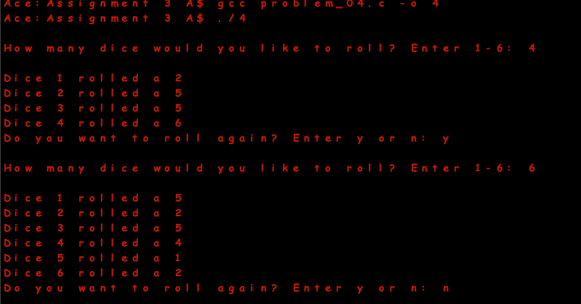

**Problem 5:**

Create a program the performs the following functions:

-Uses character arrays to read a users name from standard input.

-Tells the user how many characters are in their name.

-Displays the users name in uppercase.

Output:

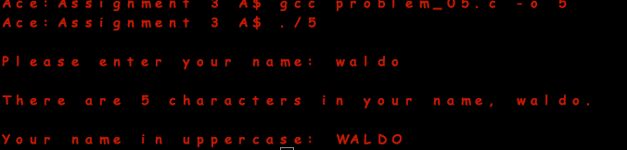

**Problem 6:**

Build a program that uses an array of strings to store the following names:

-“Florida”

-“Oregon”

-“California”

-“Georgia”

Using the preceding array of strings, write your own sort() function to display each states name in alphabetical order using the strcmp() function.

Output:

